**How Does P300 Relate to Belief Updating in Different Learning Conditions?**

Reza Hakimazar

Universität Hamburg

71-03.511 PA Res Projektarbeit I+II: Experiments in Cognitive Neuroscience (SoSe 24)

Dr. Alexa Ruel

July 24, 2024

**Introduction**

Humans have the capacity to learn from changes in their environment and adjust their knowledge accordingly (Nassar et al., 2019). We test our knowledge intentionally or unintentionally in different situations and modify what we have learned based on the outcome. In the process of learning, several factors affect our gained knowledge, such as volatility (Behrens et al., 2007; Pulcu & Browning, 2017) and prediction errors.

Prediction error is a crucial concept in reinforcement learning., but also in attention and motivation. (Den Ouden et al., 2012). Schultz et al. (1997) showed the neural foundantaions of prediction error and its effect on future decisions their fundamental study. Agents use prediction errors as a means to update their previous knowledge to perfom better in future scenarios (Efron, 2004).

More specifically, state prediction errors (SPE) act as a comparator between the current and previous state. SPE is a measure of surprise in new situations given the outcomes of previous states (Gläscher et al., 2010). In other words, SPEs evaluate the discrepancy between the potentioal outcome of the current situation and a previous event and anticipates the level of surprise based on this discrepancy.

However, no two states are identical. P300, which has been previously shown to have a strong association with belief updating and learning adjustment, can be context-dependent, which means that it elicits differently in different states (Nassar et al., 2019). Therefore, in this study we focus of the nuances of P300 in different learning conditions. In addition, we investigate behavior and its relation to the P300.

We hypothesize that, a higher P300 will be elicited in more surprising conditions, namely oddball rare conditions of the task. Moreover, we anticipate that the more surprising a condition, the less accurate the participants will be. At last, we hypothesize that participants will regain their level of accuracy in the next trial after the surprising trial.

**Methods & Procedure**

*Procedure*

6 healthy adults, including three males and three females (*m*age = 25.17, *SD* = 2,03 years), from an EEG course at the University of Hamburg volunteered to participate in this study and were compensated with course credits. The participants could choose their preferred appointment to come to the lab via an online registration form. After arrival, the participants’ heads were measured to find the suitable the EEG cap. Then the cap was populated on a model’s head followed by applying the populated cap on the participant’s head. At last, they were presented by a learning task. The whole procedure of applying the EEG cap and performing the task was done in a 180 minute time window for each participant.

*Learning Task*

The participants were presented by a learning task -the bus task-.The task began with a yellow fixation cross in the middle of the monitor for 500ms. Then house was appeared to indicate the choice of interest for 750ms followed by a fixation cross for 500ms. After that, the busses were appeared for 750ms that the participants had to choose by pressing the corresponding buttons. Then a fixation cross was appeared after 300ms or 700ms of the bus choice for 500ms and the house associated with the chosen bus was presented as a feedback, accompanied by a warning sign solely in practice trials. At last, a 1500ms long fixation cross was presented to end the trial. If a participant pressed a button before the onset of the buses, a prompt popped up with the text “too fast!”. In the opposite condition, if the participant did not choose any of the busses a prompt appeared with the text “too slow!”.

**Figure 1.**

*Depiction of Trials*

**a**

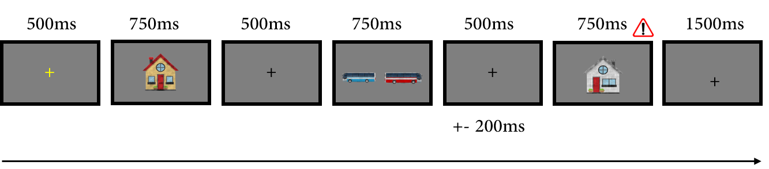

**b**

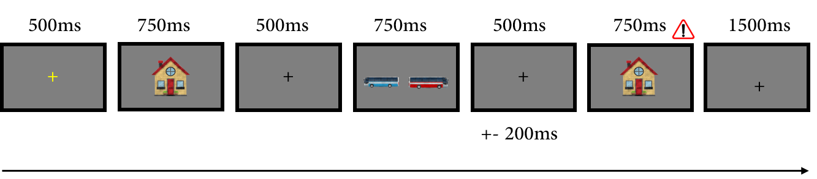

*Note*. The whole trial lasted from 3,550ms to 3,950ms. In figure (a) an expectancy violation is depicted, which indicates a surprising condition. The participant chose bus associated with the yellow house, however, the white house appeared on the screen as a feedback. In figure (b) no expectancy violation is illustrated, because the house associated with the chosen bus is appeared.

The task comprised two conditions namely oddball and reversal learning, which both had two associations. In the reversal learning condition 80 percent of the trials are common trials, which follow the instructed ans usual task structure. The remaining 20 percent of the trials are those, in which an association is switched to another called rare trials. In the oddball condition, the same logic applies in terms of the number of associations. However, in this condition 80 percent of the trials belong to one association forming the oddball common trials and the remainder shape the oddball rare trials, in which the task switches from on association to another similar to the rare trials in thee reversal learning condition. To compare the associations in each condition, one block is required in reversal learning condition, as opposed to two blocks of different associations in the oddball condition.

Each participant completed 7 blocks of practice trials without any time pressure and 9 experimental blocks (3 reversal learning and 6 oddball conditions), with 60 trials in the reversal learning blocks and 30 trials in the oddball blocks. Hlf of the participants beginned the task with oddball blocks first and the other half started with reversal learning blocks. 20 percent of both blocks consisted of surprise events.

*EEG Data Preprocessing*

The preprocessing steps were mainly inspired by the instructions of Luck (2014) in MATLAB (Mathworks, Natick MA) through EEGLAB package (Delorme & Makeig, 2004). The EEG data were recorded using 64 electrodes in a 10-20 system with a BrainVision recorder (Brainvision Recorder vers. V. 1.25.0202 Brain Products GmbH, Gliching, Germany) at a 500Hz sampling rate, while the ground electrode was located at Fpz and the reference electord at FCz. Data were rereferenced to the average of left and right mastoids. During the initial visual inspection no bad channels were identified in any participant, therefore no channels were interpolated. The raw data was filtered with a 0.5 Hz to 30 Hz band pass and segmented into 1500 ms epochs, starting at 500 ms before the stimilui onset until 1000 ms after it in each trial. . In average 10 epochs per participant -less than 3 percent of the epochs- were removed in the secondary visual inspection.

The data were baseline corrected at 500 ms before the stimuli until its onset. To remove the artifacts an independent component analysis (ICA) was utilized in two steps. ICA was first ran without removing any components followed by manually rejecting the artifacts. Artifacts such as eye blinks, heart beat, head movements, and impedances were removed in this stage, however, no additional components were excluded due to the potential risk of mistaking genuine neural activity for artifacts.

*Behavioral Data Preprocessing*

All of the behavioral data preprocessing was done in RStudio using MuMIn (Bartoń, 2010), broom (Robinson et al., 2014), tidyr (Wickham et al., 2014), ggplot2 (Wickham, 2016), lme4 (Bates et al., 2015), lmerTest (Kuznetsova et al., 2017), broom.mixed (Bolker & Robinson, 2018), and dplyr (Wickham et al., 2023).

**Results**

*EEG Analysis*

Participants showed higher P300 ERPs in reversal learning trials (*m* = 5.74, *SD* = 4.06) than oddball trial types (*m* = 5.01, *SD* = 2.84). As it is evident in Figure 4 and 5, the common trials elicited lower amplitudes, especially in oddball common trials (*m* = 4.07, *SD* = 2.05).

To investigate how P300’s amplitude is related to the expectancy violation and learning in different conditions, we conducted a mixed-effects regression analysis for each condition and their corresponding trial types. The results indicate significant effect of P300 in all conditions and trial types, especially where the associations switched.

For the sake of robustness, initially we selected random timepoints within the 300 to 400ms timeframe from the grandaveraged EEG data and gathered three different datasets from these timepoints.We centered the data towards the conditions. In this method, we allovated numerical values to conditions resulting in oddball conditions possessing -1 and reversal learning trials possessing +1. This enabled us not only to avoid dummy data but it also facilitated the identification of the relationships’ directions.

Then we fitted a mixed-effects regression model in RStudio using lme4 package (Bates et al., 2015) to each dataset separately to. To identify the value of amplitude, the coefficients, standard errors and other parameters for each trial type and condition and their interactions (see. Appendix 1) were calculated through this equation:

$${amplitude}_{ij}= β_{0}+ β_{1}{condition}_{i}+ β_{2}trialtype+ β_{3}\left(condition*trialtype\right)i+u_{j}+ ϵij$$

In this equation, $β_{0}$ is the intercept, $β_{1}$ is the coefficient for the trial type, $β_{2}$ is the coefficient for the conditions, $β_{3}$ coefficient accounts for the interaction between conditions and trial types, $u_{j}$ is the random intercept for subject $j$, and $ϵij$ shows the residual error.

The random effects of the fitted linear mixed-effects model showed a standard deviation of 3.090697 for the intercept and 1.207117 for the residual. The fixed effects estimates analysis yielded intercept (β = 4.853, SE = 1.262, t(3663) = 3.846, p < .001), condition (β = 0.290, SE = 0.020, t(3663) = 14.572, p < .001), trial type (β = -0.519, SE = 0.020, t(3663) = -26.059, p < .001), and the interaction between condition and trial type (β = -0.073, SE = 0.020, t(3663) = -3.667, p < .001). Overall, the analysis indicates significant and strong effects for conditions and trial types. Their interaction effect is weaker but significant.

**Figure 2.**

*Interaction Plot of Condition and Trial Type Predicting the Amplitude Value*

*Note*. The plot shows a higher mean amplitude value in reversal learning conditions for both trial types. In addition, rare trials elicit a higher amplitude in both conditions compared to common trials.

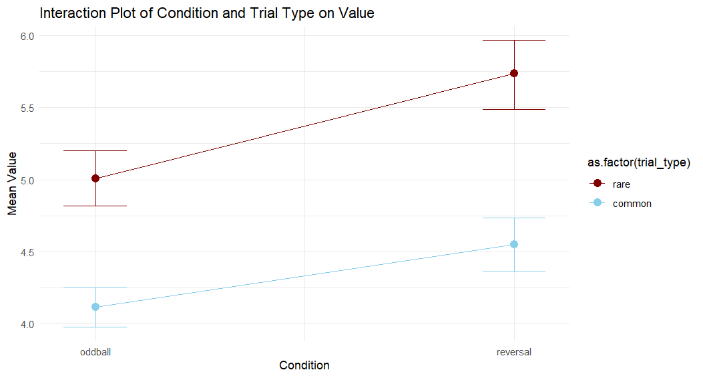

**Figure 3.**

*Point Plot of the Amplitude Value by Condition and Trial Type*

*Note*. Pointplot was used instead of a boxplot due to a its higher capability depiction of variabilities.

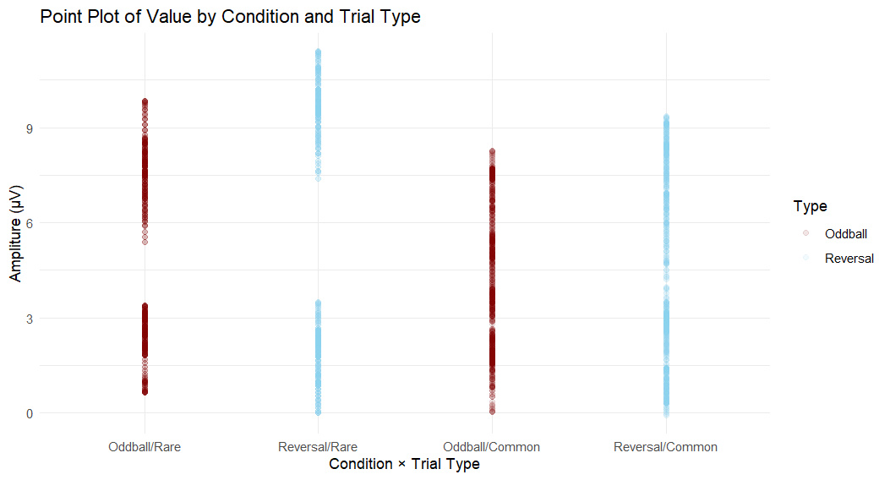

**Figure 4.**

*Topographies for conditions and trials types*

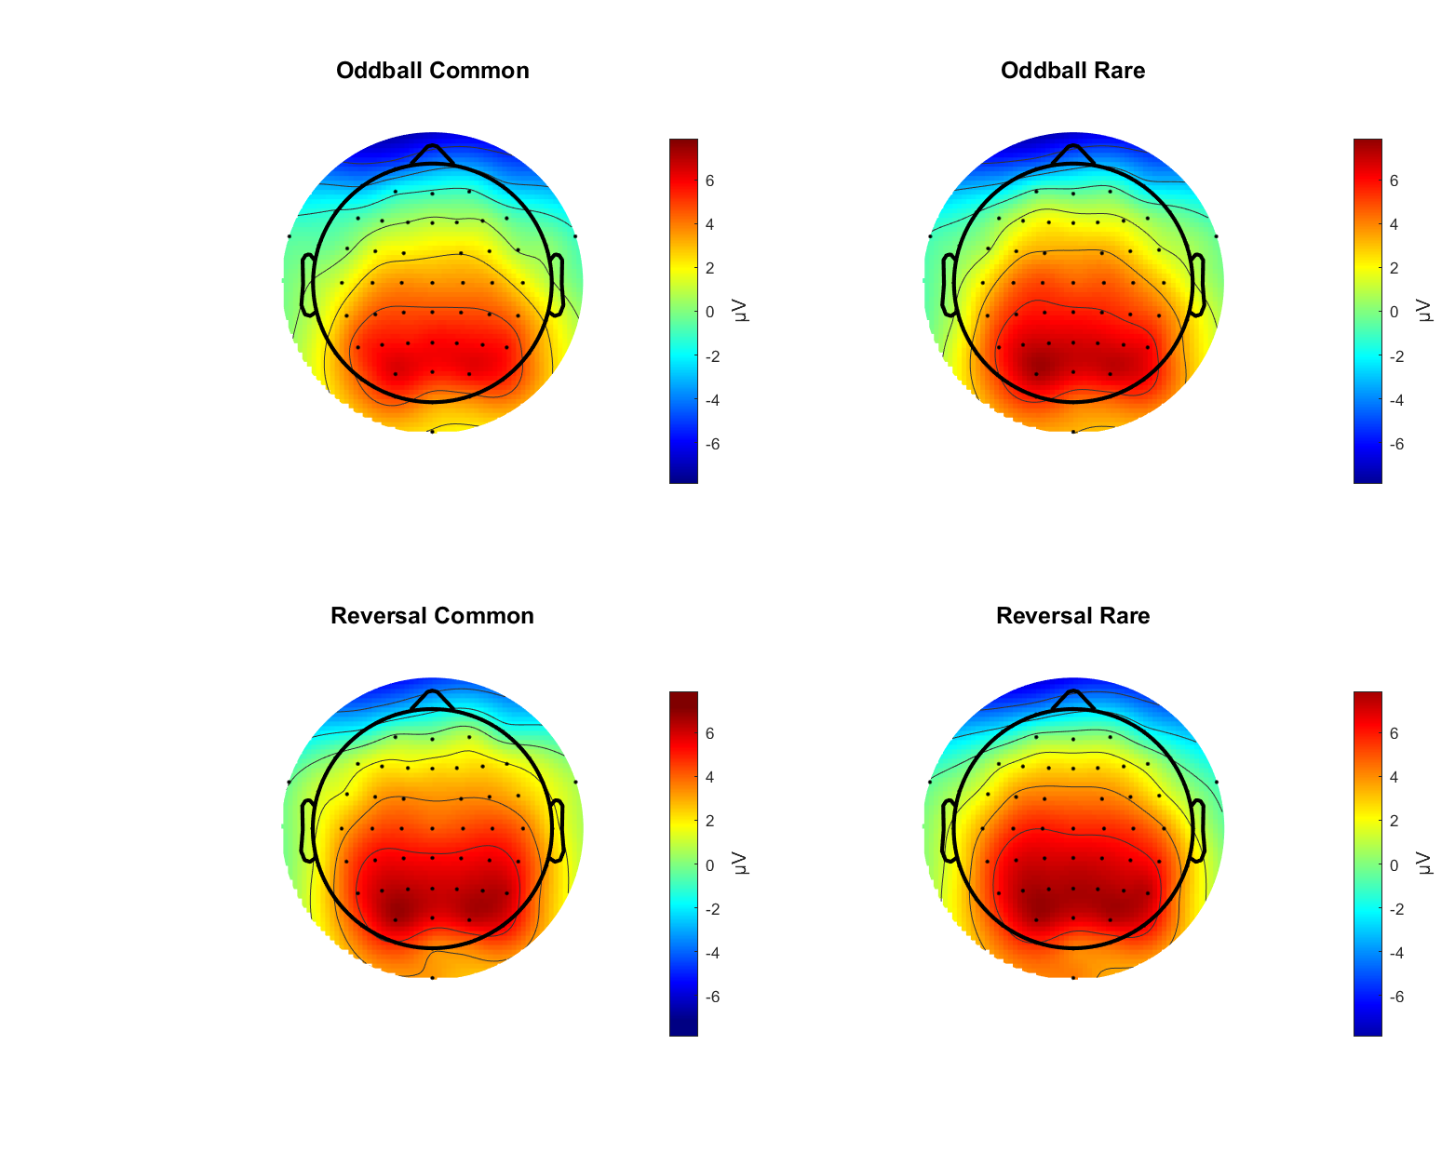

*Note.* These plots indicate brain activation in the ROI during a 300ms-400ms timeframe. Parallel to the previous analysis a higher activation in the parietal region can be seen during reversal learning conditions and rare trials.

**Figure 5.**

*Grand Averaged P300 components at ROI*

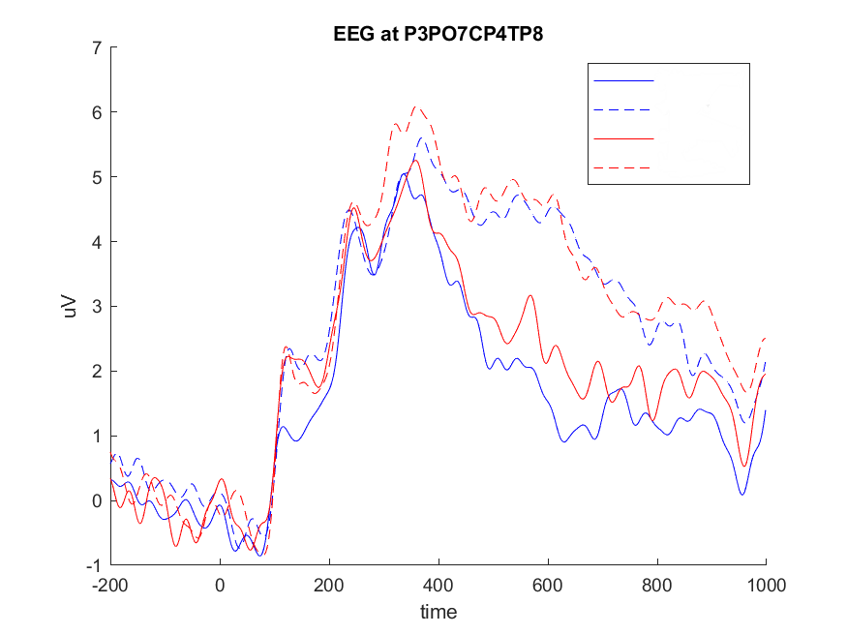

**Oddball/Common**

**Oddball/Rare**

**RL/Common**

**RL/Rare**

*Note*. The ROI of Pz, CPz, P1 and P2 the electrodes.

*Behavioral Analysis*

Participants performed somewhat similar in oddball condition (m = 0.70, SD = .46, min = 0.56 , max = 0.76) and reversal learning conditions (m = 0.70, SD = 0.46, min = 0.66 , max = 0.74). The same applied for reaction times in these conditions (oddball: min = 329.21ms, max = 433.193ms, m = 364.56ms, SD = 8.26ms; reversal learning: min = 305.77ms , max = 410.96, m = 356.43ms, SD = 7.54ms).

However, unsurprisingly, in rare trial types participants perfomed with lower accuracy (*m*rare = 0.07, *SD*rare = 0.25) than in common trials (*m*common = 0.83, *SD*common = 0.37). Similar to conditions, in trial types pearticipants seem to perform similar in different trial types in terms of reaction times (oddball: *m*rare = 0.36, *SD*rare = 0.12; *m*common = 0.35, *SD*common = 0.12; reversal learning: *m*surprise = 0.37, *SD*surprise = 0.10; *m*common = 0.37, *SD*common = 0.19).

Participants learned how to perform better in rare trials as t-test shows a significant difference in terms of accuracy in rare trials and their following trials in both oddball (*t*(351.04) = 17.15, *p* < 0.001, *CI* = [0.56, 0.71])and reversal learning conditions (*t*(318.84) = 17.81 , *p* < 0.001, *CI* = [0.57, 0.71]).

As depicted in Figure 6, participants performed significantly wore in the subsequent trial after rare trials in both conditions (oddball: *t*(352.39) = 4.99, *p* < 0.001, *CI* = [0.11, 0.26]; reversal learning:

*t*(376.51)= 4.35, *p* < 0.001, *CI* = [0.09, 0.25]).

Potentially due to a limited sample size, correlational analysis of subsequent accuracy did not yield significant results in neither conditions when EEG P300 amplitude was accounted for (oddball: *r* = 0.27, *p* = 0.61; reversal learning: *r* = 0.66, *p* = 0.16)

**Figure 6.**

*Mean Accuracy in Trials, Preceding and Proceedeing Rare Trials*

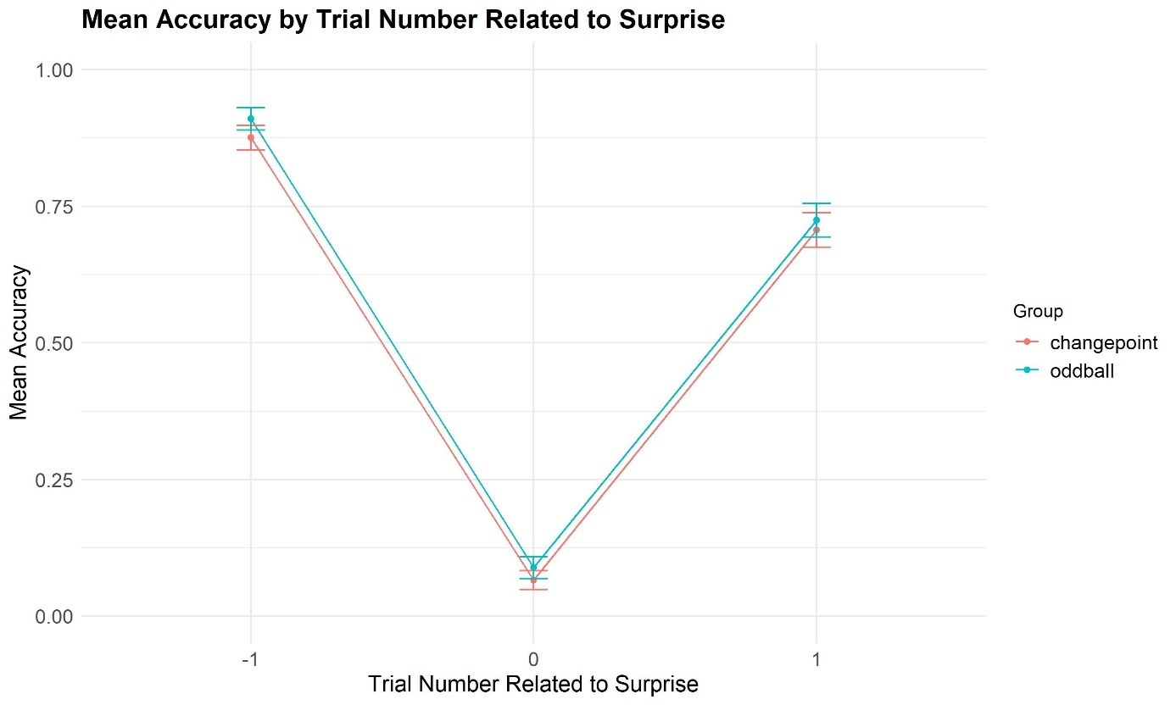

reversal learning

oddball

Trial Type

*Note*. Participants performed less accurate in rare trials in both conditions. They also could not regain their previous accuracy in trials immediately after rare trials (+1) and performed at a lower level than before (-1).

**Discussion**

Appendix 1: *Mixed-effects Regression Analysis for the 3 Extracted Datasets*

**Table 3.1**

*Mixed-effects Regression Analysis: Dataset 1*

|  |  |  |  |  |  |
| --- | --- | --- | --- | --- | --- |
| Effect | Amplitude Estimate (β) | *SE* | *p* | *t* | *SD* |
| Fixed effects |  |  |  |  |  |
| Intercept | 4.81 | 1.24 | .0001 | 3.85 |  |
| Condition a | .26 | .028 | .0000 | 7.70 |  |
| Trial typeb | −.56 | .018 | .0000 | -16.03 |  |
| Condition × Trial type c | −.10 | .001 | .0007 | -2.67 |  |
| Random effects |  |  |  |  |  |
| Intercept |  |  |  |  | 3.05 |
| Residuals |  |  |  |  | 1.22 |

**Table 3.2**

*Mixed-effects Regression Analysis: Dataset 2*

|  |  |  |  |  |  |
| --- | --- | --- | --- | --- | --- |
| Effect | Amplitude Estimate (β) | *SE* | *p* | *t* | *SD* |
| Fixed effects |  |  |  |  |  |
| Intercept | 4.81 | 1.24 | .0001 | 3.85 |  |
| Condition a | .26 | .028 | .0000 | 7.70 |  |
| Trial typeb | −.56 | .018 | .0000 | -16.03 |  |
| Condition × Trial type c | −.10 | .001 | .0007 | -2.67 |  |
| Random effects |  |  |  |  |  |
| Intercept |  |  |  |  | 3.05 |
| Residuals |  |  |  |  | 1.22 |

**Table 3.3**

*Mixed-effects Regression Analysis: Dataset 3*

|  |  |  |  |  |  |
| --- | --- | --- | --- | --- | --- |
| Effect | Amplitude Estimate (β) | *SE* | *p* | *t* | *SD* |
| Fixed effects |  |  |  |  |  |
| Intercept | 4.93 | 1.29 | .0001 | 3.85 |  |
| Condition a | .33 | .03 | .0000 | 10.11 |  |
| Trial typeb | −.43 | .03 | .0000 | −13.24 |  |
| Condition × Trial type c | −.03 | .03 | .32 | −.97 |  |
| Random effects |  |  |  |  |  |
| Intercept |  |  |  |  | 3.17 |
| Residuals |  |  |  |  | 1.14 |

*Note*. (a) oddball or reversal learning, (a) common or rare,  (c) interaction of trial types and conditions

**References**

Bartoń K (2010). MuMIn: Multi-Model Inference. R package version 1.43.17, https://CRAN.R-project.org/package=MuMIn.

Bates D, Mächler M, Bolker B, Walker S (2015). Fitting Linear Mixed-Effects Models Using lme4. Journal of Statistical Software, 67(1), 1-48, https://doi.org/10.18637/jss.v067.i01.

Behrens, T. E. J., Woolrich, M. W., Walton, M. E., & Rushworth, M. F. S. (2007). Learning the value of information in an uncertain world. *Nature Neuroscience*, *10*(9), 1214–1221. <https://doi.org/10.1038/nn1954>

Bolker B, Robinson D (2018). broom.mixed: Tidying Methods for Mixed Models. R package version 0.2.4, https://CRAN.R-project.org/package=broom.mixed.

Daw, N. D., Gershman, S. J., Seymour, B., Dayan, P., & Dolan, R. J. (2011). Model-Based Influences on Humans’ Choices and Striatal Prediction Errors. *Neuron*, *69*(6), 1204–1215. <https://doi.org/10.1016/j.neuron.2011.02.027>

Delorme A & Makeig S (2004) EEGLAB: an open-source toolbox for analysis of single-trial EEG dynamics, Journal of Neuroscience Methods 134:9-21.

Den Ouden, H. E., Kok, P., & De Lange, F. P. (2012). How Prediction Errors Shape Perception, Attention, and Motivation. *Frontiers in Psychology*, *3*. <https://doi.org/10.3389/fpsyg.2012.00548>

*EEGLAB References*. (n.d.). EEGLAB Wiki. Retrieved July 10, 2024, from <https://eeglab.org/others/EEGLAB_References.html>

Efron, B. (2004). The Estimation of Prediction Error: Covariance Penalties and Cross-Validation. *Journal of the American Statistical Association*, *99*(467), 619–632. <https://doi.org/10.1198/016214504000000692>

Gläscher, J., Daw, N., Dayan, P., & O’Doherty, J. P. (2010). States versus Rewards: Dissociable Neural Prediction Error Signals Underlying Model-Based and Model-Free Reinforcement Learning. *Neuron*, *66*(4), 585–595. <https://doi.org/10.1016/j.neuron.2010.04.016>

Kuznetsova A, Brockhoff PB, Christensen RHB (2017). lmerTest Package: Tests in Linear Mixed Effects Models. Journal of Statistical Software, 82(13), 1-26, https://doi.org/10.18637/jss.v082.i13.

Luck, S. J. (2014). *An introduction to the event-related potential technique*. MIT press. <https://books.google.com/books?hl=en&lr=&id=y4-uAwAAQBAJ&oi=fnd&pg=PR5&dq=info:uHgzBM0KKlAJ:scholar.google.com&ots=jDZZF8MUDC&sig=ArRIIIIgwONHTc6Z4OLhSk-PTqc>

Nassar, M. R., Bruckner, R., & Frank, M. J. (2019). Statistical context dictates the relationship between feedback-related EEG signals and learning. *eLife*, *8*, e46975. <https://doi.org/10.7554/eLife.46975>

Pulcu, E., & Browning, M. (2017). Affective bias as a rational response to the statistics of rewards and punishments. *eLife*, *6*, e27879. <https://doi.org/10.7554/eLife.27879>

Robinson D, Hayes A, Couch S, Ogle D (2014). broom: Convert Statistical Analysis Objects into Tidy Data Frames. R package version 0.7.0, https://CRAN.R-project.org/package=broom.

Schultz, W., Dayan, P., & Montague, P. R. (1997). A Neural Substrate of Prediction and Reward. *Science*, *275*(5306), 1593–1599. <https://doi.org/10.1126/science.275.5306.1593>

*The MathWorks Inc. (2022). MATLAB version: 9.13.0 (R2022b), Natick, Massachusetts: The MathWorks Inc. Https://www.mathworks.com*. (n.d.). [Computer software].

Wickham H (2016). ggplot2: Elegant Graphics for Data Analysis. Springer-Verlag New York, https://ggplot2.tidyverse.org.

Wickham H, François R, Henry L, Müller K, Vaughan D (2023). dplyr: A Grammar of Data Manipulation. R package version 1.1.4, https://dplyr.tidyverse.org.

Wickham H, Henry L, Girlich M (2014). tidyr: Tidy Messy Data. R package version 1.2.0, https://CRAN.R-project.org/package=tidyr.